IT2120 - Probability and Statistics

Name: Thuvaragan. B

IT No: IT24103754

Exercise 1

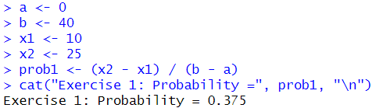

Exercise 2

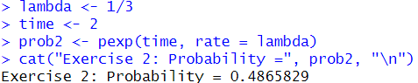

Exercise 3

